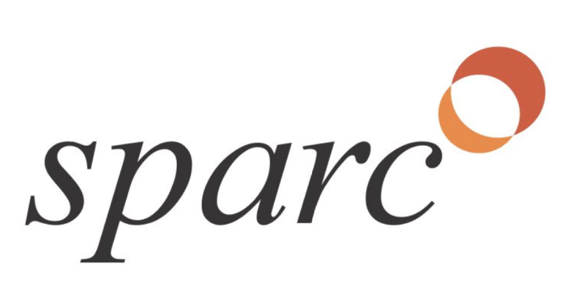
SPARC FULL PROPOSAL

  - INSTRUCTIONS:

In this document, you will draft a full proposal on your project for SPARC. A successful proposal to SPARC will be referenced in an executed collaboration agreement under the SPARC-WUSTL Master Services Agreement for your technology.

Please reference the “Guidelines for SPARC Full Proposal FALL2018” document that has been provided to you.

Full Proposal Outline:

- SECTION 1: MARKET & NEED - 1 page
  - What is the unmet need your project addresses? What is the competition?
- SECTION 2: THE TARGET PRODUCT PROFILE - 1 page
  - Describe the advantages over the standard of care
- SECTION 3: CLINICAL TRIAL CONSIDERATIONS – 1 page
  - Outline your initial clinical trial
- SECTION 4: PROJECT STAGE, GOALS, & PLAN
  - CURRENT PROJECT STAGE – 2 pages
    - Description of the current status of data to demonstrate proof of concept.
  - DEVELOPMENT MILESTONES – 1 page
    - What are the aims of the collaboration?
  - DETAILED DEVELOPMENT PLAN – 3-5 pages (w/o tables)
    - What activity is planned to achieve the DEVELOPMENT MILESTONES?
    - Who will perform this work and how will it be funded?

Total pages= 11 maximum w/o tables

Please delete italic text in the final draft. Your responses should not be in italics.

[PI Name] FULL PROPOSAL

Project Title: (Product description) for (indication)

Lead Investigator: Full name, official university title

Lead Investigator e-mail:
Executive Summary: See Template Guide for content guidelines.

Key Project Leadership: See Template Guide for content guidelines.

SECTION 1:

THE MARKET & NEED – 1 PAGE

Unmet Need/Target Market: See Template Guide for content guidelines.

Compound | Company | Mech. Of Action | Development Stage

Compound | Company | Mech. Of Action | Development Stage

SECTION 2:

THE TARGET PRODUCT PROFILE – 1 PAGE
Differentiation/Advantages over Standard of Care: See Template Guide for content guidelines.

Target Product Profile to Differentiate from Standard of Care
Ideal Target / Claim | Min. Acceptable Target / Claim | Required Evidence
SECTION 3:

CLINICAL TRIAL CONSIDERATIONS – 1 PAGE

See Template Guide for content guidelines.

SECTION 4: PROJECT STAGE, GOALS, & PLAN

The purpose of this section is to go deeper into the data & current status of the project and outline a detailed plan with milestones for development.

CURRENT PROJECT STAGE – 2 PAGES
See Template Guide for content guidelines.

Intellectual Property – 1 Paragraph

See Template Guide for content guidelines.

DEVELOPMENT MILESTONES, DECISION POINTS, & SUCCESS MILESTONE

– 3-5 PAGES w/o tables

See Template Guide for content guidelines.

SUCCESS MILESTONE: | IDENTIFICATION & VALIDATION OF A CLINICAL THERAPEUTIC CANDIDATE.” Put this in your own language for your project.

DEVELOPMENT MILESTONES  / DECISION POINTS: | [Type of Activity]  - KEY GO/NO-GO DATA THRESHOLD TO BE ACHIEVED – MONTH/YEAR  - Specific activity  - Specific activity  - Decision Point 1 (DP1)  - KEY GO/NO-GO DATA THRESHOLD TO BE ACHIEVED – MONTH/YEAR  - Specific activity  - Specific activity  - Decision Point 2 (DP2)  [Type of Activity]  - KEY GO/NO-GO DATA THRESHOLD TO BE ACHIEVED – MONTH/YEAR  - Specific activity  - Specific activity  - Decision Point 3 (DP3)  - [add more as needed]  - Specific activity  - Specific activity  - Decision Point 4 (DP4)

DETAILED DEVELOPMENT PLAN
Overall the Detailed Development Plan consists of three things:
- Written Description of Development Milestones
- Development Milestone Flowchart or GANTT Chart
- Use of Funds Table
See Template Guide for content guidelines.

- Written Description of Development Milestones
See Template Guide for content guidelines.

Assay / Experiment / Activity (Special reagents Needed) | Group Performing Work | Specific Data Readouts
[Description of specific activities required under this tranche – EACH EXPERIMENT IS ITS OWN LINE, add as many lines as needed] – (Describe any particular needs for reagents to complete the activity in parentheses)  This is NOT: “In vitro testing” or “Demonstrate manufacturability”  This IS: “Testing Patency and Efficacy in a diabetic pig model on 8 pigs” | [PI last name] Lab or Acronym | [specific success criterion for the deliverable which is clearly “go/no-go”]  This is NOT: “Favorable Pharmacokinetics” OR  This IS:  - “Demonstration of a 2-4 hour half life and measurable biomarker  - “Reproducibility of survival outcomes within 15%”

- Development Milestone Flowchart or GANTT Chart
See Template Guide for content guidelines.

- Use of Funds Table(s)
See Template Guide for content guidelines.

USE OF FUNDS TABLE
SPARC COLLABORATION – YEAR 1
Fund Source: SPARC
Associated Development Milestone Number | Assay / Experiment / Activity (Reagents Needed) | Funds required / Group Performing Work | Specific Data Readouts | Delivery by
[Input the number of the of the Development Milestone that the assay or experiment falls under.] | [Description of specific activities required under this tranche – EACH EXPERIMENT IS ITS OWN LINE, add as many lines as needed] – (Describe any particular needs for reagents to complete the activity in parentheses)  This is NOT: “In vitro testing” or “Demonstrate manufacturability”  This IS: “Evaluating efficacy in a diabetic pig model, n=8” | [$] – [PI last name] Lab, Group Acronym, or Company (e.g. SPARC in-kind) | This is NOT: “Favorable Pharmacokinetics” OR “Confirmation of mechanism”  This IS:  - “Demonstration of a 2-4 hour half life”  - “Positive correlation of target occupancy & plasma levels with desired phenotypic outcome in dose response”  - “A safety margin of 40% minimally efficacious dose”  - “Reproducibility of survival outcomes within 15%” | [Month Year]
Sub-total SPARC funds |  | Max Direct ~$160,000
Fund Source: non-SPARC
Fund Source | General Aims | Funds Available | Associated Development Milestone Number / How does this help acheive Development Milestone(s)?
[Granting Agency or other source] | [Description of applicable aims] | [Total funds available / Funds in-Hand or not] | [#] - [How does this help achieve Development Milestone?]
Sub-total Non-SPARC funds |  | $X

DEVELOPMENT PLAN & USE OF FUNDS TABLE
SPARC COLLABORATION – YEAR 2
Fund Source: SPARC
Associated Development Milestone Number | Assay / Experiment / Activity (Reagents Needed) | Funds required / Group Performing Work | Specific Data Readouts | Delivery by
Sub-total SPARC funds |  | Max Direct ~$160,000
Fund Source: non-SPARC
Fund Source | General Aims | Funds Available | Why is this applicable to your Key Development Milestone?
Sub-total Non-SPARC funds |  | $X

DEVELOPMENT PLAN & USE OF FUNDS TABLE
SPARC COLLABORATION – YEAR 3
Fund Source: SPARC
Associated Development Milestone Number | Assay / Experiment / Activity (Reagents Needed) | Funds required / Group Performing Work | Specific Data Readouts | Delivery by
Sub-total SPARC funds |  | Max Direct ~$160,000
Fund Source: non-SPARC
Fund Source | General Aims | Funds Available | Why is this applicable to your Key Development Milestone?
Sub-total Non-SPARC funds |  | $X

